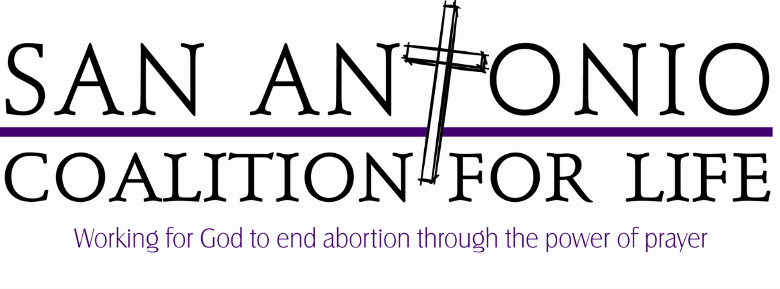
Statement of Peace

I, ____________________________________________, testify to the following:
Print Name

- I will only pursue peaceful solutions to the violence of abortion when volunteering with the 40 Days for Life campaign
- I will show compassion and reflect Christ’s love to all Planned Parenthood employees, volunteers, and customers
- I understand that acting in a violent or harmful manner immediately and completely dissociates me from the 40 Days for Life campaign
- I am in no way associated with Planned Parenthood or its affiliates by way of employment, informant, volunteer, client, or otherwise

While standing in the city right of way in front of Planned Parenthood:

- I will not obstruct the driveways or sidewalk while standing in the public right of way
- I will not litter on the public right of way
- I will closely attend to any children I bring to the prayer vigil
- I will not threaten, physically contact, or verbally abuse Planned Parenthood employees, volunteers, or customers
- I will not vandalize private property
- I will cooperate with local city authorities

Signature: _________________________________Date:__________________

Contact Information (Please print neatly):
Address: _________________________________________________________
City: ___________________________ State: _____________ Zip:___________
Email: ___________________________________________________________
Phone: __________________________________________________________

